Software Requirements Specification

for

Temperature Control System

Version 1.0 approved

Prepared by Doruk Arslan, Doğuhan Cumaoğlu, Alp Keskin, Hasanalp Temiz

TED University

16.12.2021

Table of Contents

1. Introduction 1

1.1 Purpose 1

1.2 Document Conventions 1

1.3 Intended Audience and Reading Suggestions 1

1.4 Product Scope 1

1.5 References 2

2. Overall Description 2

2.1 Product Perspective 2

2.2 Product Functions 3

2.3 User Classes and Characteristics 4

2.4 Operating Environment 5

2.5 Design and Implementation Constraints 5

2.6 User Documentation 5

2.7 Assumptions and Dependencies 6

3. External Interface Requirements 6

3.1 User Interfaces 6

3.2 Hardware Interfaces 7

3.3 Software Interfaces 7

3.4 Communications Interfaces 7

4. System Features 8

4.1 Login 8

4.2 Control unit implementation 9

4.3 Add User Information 9

4.4 Show Estimated Bill Amounts 10

4.5 Automation on/off 11

4.6 Querying the weather 12

4.7 Energy Saving Mode 13

4.8 Read logs 14

4.9 Emergency 15

4.10 Network Loss Handling 16

4.11 Show recommended adjustments 17

5. Other Nonfunctional Requirements 18

5.1 Performance Requirements 18

5.2 Safety Requirements 18

5.3 Security Requirements 18

5.4 Software Quality Attributes 18

5.5 Business Rules 19

6. Other Requirements 20

6.1 Appendix A: Glossary 20

6.2 Appendix B: Analysis Models 20

6.3 Appendix C: To Be Determined List 20

Revision History

|  |  |  |  |
| --- | --- | --- | --- |
| **Name** | **Date** | **Reason For Changes** | **Version** |
|  |  |  |  |
|  |  |  |  |

# Introduction

## Purpose

This system is the integration of the heat control system into smart homes with IoT technology. Users can adjust the temperature of their homes remotely or manually, regardless of the season. Thanks to some technologies (air conditioning, central heating systems) in the house and integrated into the system, the temperature of the house can be adjusted. In addition, this system can contact the emergency centers and intervene in any overheating or overcooling situations at home, by informing the user according to the urgency of the situation or directly.

## Document Conventions

This document was prepared by MLA Format. The bold-faced text has been used to highlight chapter and subsection titles. All text contained in this document is 12pt Arial font. Section titles are 18pt Arial font. Subsection titles are 14pt Arial font. The chapter titles are in 18pt Arial font. The subdivision headings are in 14pt Arial font. All sections and subsections X.X.X. The numbers that use the format represent the numbers. Document text will be single-spaced and maintain 1” margins.

## Intended Audience and Reading Suggestions

This document is intended to provide developers, marketing personnel, project managers and testers, as well as documentation authors with information so that they can understand the scenario. Users have access to different module formats in the system, depending on their functionality.

Suggested sequences for readers: (1-Introduction, 2-Overall Description, 3-External Interface Requirements, 4-System Features, 5-Other Non-functional Requirements, 6-Other Requirements)

Developers & Project Managers: 2-3-4-5-1-6

Marketing Staffs: 1-2-4-5-6-3

Testers: 2-6-5-4-3-1

Document Writers: 1-2-3-4-5-6

## Product Scope

The project is a system for controlling the temperature settings of people's homes and which can be adjusted autonomously or manually according to various situations. Nowadays, various devices and electrical systems, lighting systems in houses, and many similar systems have become autonomous structures that do not need people's control and have managed to save people time and economy. The temperature control system in the houses should also become autonomous, and various services related to this issue are provided in our project. Thanks to these systems, time and money can be saved. In addition, the loss of life and property can be easily prevented thanks to the emergency.

## References

- <https://creately.com/diagram-type/sequence-diagram>

- <https://www.perforce.com/blog/alm/how-write-software-requirements-specification-srs-document>

-https://krazytech.com/projects/sample-software-requirements-specificationsrs-report-airline-database

# Overall Description

## Product Perspective

The temperature control System is a completely new, original product. The product is a super system that includes all the systems it detects and creates an ecosystem, rather than a self-contained system because it controls all the temperature and air systems in the house. In addition, all hardware and software parts of the system are manufactured in Turkey, but they will be available not only locally, but also on the global market. That is why the product has various language options in it.

**User Information:**

* The information that users enter after logging in is the information that the system needs, such as address, phone number, first name, last name. In order to take advantage of all the features of the temperature control system, the user must also enter information such as their average monthly salary, the number of people living in the house, etc.

**Smart Components Information:**

* It is the information about the temperature and ventilation devices in the house that users introduce to the system. It contains information about the models of devices, their types, how they are used and what features they have. This is very important information for the implementation of devices to the temperature control system.

**Weather Information:**

* It is information about the daily weather in the region where the user lives that is provided using the Api that we provide from the Openweather.com. In addition, the device stores data by measuring the average daily temperature in the area where the user lives on its own.

**Emergency Information:**

* It is the user's address that will be used in emergency situations, as well as information such as fire stations and phone numbers that are closest to this address.

**Logs Information:**

* It is information obtained from home and from the user that contains reports created by preparing and analyzing the information obtained. As a result of this information, the temperature control system can work more efficiently, and if the user agrees, the information can also be used for commercial purposes.

## Product Functions

The Temperature Control System,

* must be implementable with heat centers in the user's home.
* must be able to perform the user's registration and login process.
* must be able to provide the user with an interface through which he can add his own information and preferences.
* must be able to pair the systems inside the user's home and incorporate them into its ecosystem.
* must be able to show the user the estimated monthly bill amount.
* must be able to show the user the recommended adjustments for the home ecosystem depending on the weather conditions.
* must be able to provide the user with the ability to turn off and on autonomous functioning.
* must be able to read the current weather data and make possible forecasts for the future.
* must be able to alert the user when the average electricity usage is exceeded and optionally switch to energy saving mode.
* must be able to alert the user in case of an emergency and be able to notify emergency teams such as the fire department of the emergency situation.
* must be able to collect the information it receives from the user and from the home and analyze them and increase its own efficiency.
* must be able to share year-end budget and temperature reports with the user.
* must be able to continue to work in offline mode with the information it collects from the user if the network is lost.

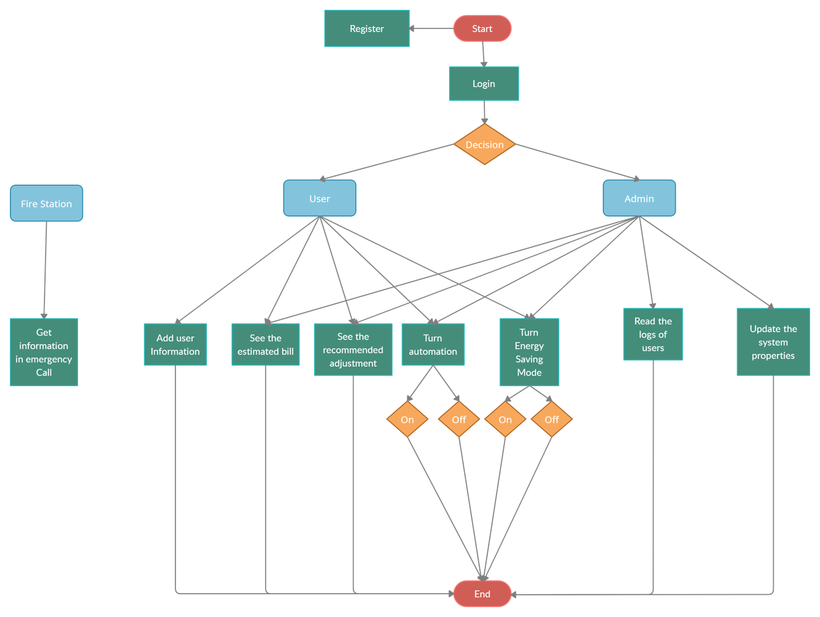

Figure[1]

## User Classes and Characteristics

The system users will have access to instant temperature information at home and will be able to query data such as air temperature in the past days, temperature in the house, amount of electricity consumed. The administrator will also have special powers other than the powers of the users. The administrator can provide access to the information of multiple houses and examine the functioning of the system at the time of errors and failures.

**The user will be able to perform the following activities:**

* Register
* Login
* Add user information
* See the estimated invoice
* See the recommended adjustment
* Turn automation on/off
* Turn energy saving mode on/off
* Pair smart components

**The Administrator will be able to perform the following activities:**

* Read the logs of user
* Update the system properties

**The Fire Station will be able to perform the following activities:**

* see the address of the user who needs help
* learning the information of weather conditions in the region

## Operating Environment

The Temperature Control System will be able to operate with:

* Client/Server systems: Azure
* Relational Database: MongoDb Atlas
* Database: Sql
* Operating System: Android, Ios
* Hardware Platform: CompactDAQ, CompactRIO

## Design and Implementation Constraints

Since the system is developed in accordance with mobile applications, it does not work with computer operating systems such as Linux, windows. Each user's own data is stored in a special local database for him, and this cannot be shared publicly with developers unless the user requests it. Although the temperature control system can automatically detect the temperature units in the house, it cannot automatically add them to its ecosystem unless the user allows it. With the limitation of the developers, the maximum number of units that can be added to the system is 10. More than 10 units cannot be integrated with the temperature control system.

## User Documentation

A user manual will also be provided to the user along with the unit that will be sent to the user's home for the implementation of the system. The user manual will contain information about how to use the temperature control system after it is implemented into the house by the user and how to pair the devices in the house with the unit. There will also be an information booklet with instructions on how to connect the system with heat centers inside the house.

## Assumptions and Dependencies

* We assume that the user is able to correctly connect the system to the temperature system in his home, and the information received from there to the unit is correct.
* We assume that the Api implemented by Openweather.com sends us the right data at the right time and there are no problems.
* We assume that the temperature devices in the user's home contain Bluetooth and can be successfully implemented with the temperature control system.
* We assume that according to the temperature inside the house, the emergency system can be properly implemented with fire stations.

# External Interface Requirements

## User Interfaces

Since the system we have built will be specific to users, the user will first encounter the Login-Register screen. On this screen, the user can log in to the system with his current membership, if he has forgotten his password, he can click on the forgot password button or he can register to become a member from scratch. After the member login, if it has not been added yet, a screen is requested to add the user information. On this screen, the user enters information that will enable the system to provide better service to the user, such as Name, Surname, Home address, room number of the house, facade of the house.

After entering this information, the user will see the home screen. On this screen, the user's name, surname, and address are in the upper right corner of the screen. At the same time, there is a settings menu at the bottom right so that the information can update its current information in case of change. Through the main screen, the user can use and access the various functions displayed in a list. When the user selects Pair Smart Components from this list view, he/she sees a screen where he/she can see and match the smart components around him/her. If the user selects Show Estimated Bill Amounts or Show Recommended Adjustments, the user is faced with a screen where various graphics are presented regarding the function he selected. If the user clicks on Energy Saving Mode or Automation on/off, he/she will see a slide button where he/she can activate or deactivate the related features.

## Hardware Interfaces

In order to communicate with the smart components in the house and interact with the application, when necessary, we need to install a microcontroller called Temperature Control Unit (TCU) inside the house. TCU can be paired with smart components in the house via Bluetooth protocol and can send various commands to these components. Therefore, it is necessary to take into account that every device to be paired with the TCU must have a Bluetooth connection. At the same time, the application must be in contact with the TCU in order to monitor and change the situation at home. Wi-Fi connection is required for connection and communication between the TCU and the application, since the user needs to use the application even when far from home (for example, from the workplace).

## Software Interfaces

Daily data is saved in the database with MongoDB technology in order not to experience performance loss in case of internet connection interruption. In this way, the Temperature Control Unit records various data in its own memory with daily queries to this database. Every completed data is deleted from the memory of the TCU at the end of the day but continues to be kept on the database for log operations. At the same time, to have information about the weather in the relevant region, it is necessary to make requests with the help of the APIs provided and save this information in the database.

## Communications Interfaces

TCP connection is used for communication all over the system except for the "Emergency Call" feature in our system. For example, File Transfer Protocol (FTP) is used for all file transfers in the System. Simple Mail Transfer Protocol (SMTP) is used for the e-mails to be sent for the reporting and billing processes of the system. In addition, the necessary updates can be made by the admin by connecting to the control systems with the SSH (Secure Shell) protocol. In addition, all connections open to the Internet use HTTPS because it encrypts all data, and it is more secure than HTTP.

In the "Emergency Call" feature, the system offers a voice assistant feature that reads the prepared text. This voice assistant calls the authorized units in case of emergency and reads the text. In this audio transmission, User Datagram Protocol (UDP) is used.

# System Features

## Login

4.1.1 Description and Priority

Users who have registered with the system can log in. As a result, they will have access to system features. It can be rated as 4 on a relative scale.

4.1.2 Stimulus/Response Sequences

When a user logs in to the system, two different options appear. To log into the system, the user must have a username and password, and the user can access the system by entering the correct information in the text field window that opens. If the username or password entered by the user is incorrect, a warning message is displayed. In such a case, the user can log in to the system with the help of a new password containing the verification code to be sent to the e-mail address or phone number by clicking on the "Forgot Password" option.

4.1.3 Functional Requirements

REQ-1: System, must be able to perform membership steps

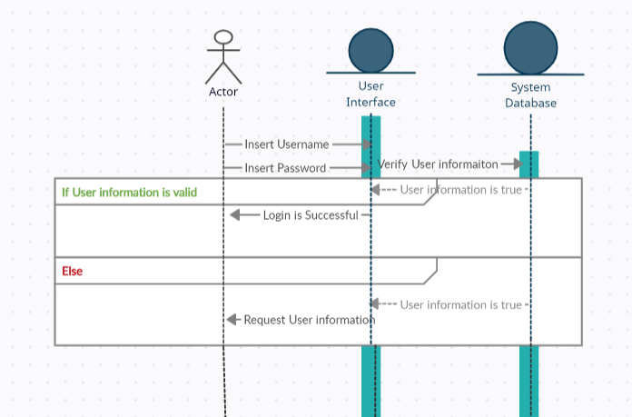

Figure[2] Sequence Diagram of Login.

## Control unit implementation

4.2.1 Description and Priority

To control and analyze the temperature values in central and floor heating centers we need to connect our Temperature Control Unit (TCU) to them. To accomplish this required electronical connections must be made by the administrative staff to provide the communication between control unit and heat centers (Radiator, combi boiler etc.). Once the control unit implementation finished, user can pair any additional smart components to the Temperature Control Unit via Bluetooth connection. Since it is the base of the system it is a high- priority feature. Hence, its rate can be considered in a relative scale as 9.

4.2.2 Stimulus/Response Sequences

Administrator staff should identify heating units such as combi boilers and heaters in the house and integrate them into the Temperature Control Unit. After this integration, the user should be able to access the TCU from the system and observe and change the values of the connected units via the application. After these processes, the user can detect various smart components that are present in the house and can be included in the system.

4.2.3 Functional Requirements

REQ-1 The temperature control unit should be integrated into the home environment.

REQ-2: The user should be able to observe and control the components connected to the TCU.

REQ-3: The system must be able to notify the fire department immediately when the critical limit is exceeded in the house (fire situation).

## Add User Information

4.3.1 Description and Priority

In order for the temperature control unit to work at maximum efficiency and to use the automation feature, some data must be obtained from the user. The user can enter information such as the number of rooms, the number of people living in the house, the desired temperature level or average of the rooms, the order of importance of the rooms. In addition, the user can enter the budget information and with this information, the system focuses on maximum efficiency without exceeding the budget limits. Apart from these, this information is kept anonymous and used for general reporting. It can rate on relative scale as 4.

4.3.2 Stimulus/Response Sequences

The information entered by the users is received and recorded in the database. The data is then analyzed, and the optimum values are returned to the user. In addition, the user can change this information at any time.

4.3.3 Functional Requirements

REQ-1: The user's entries must be saved in the database.

REQ-2: The user's data should be processed on the main server and the optimum values should be returned to the user.

REQ-3: All information should be kept anonymous and reported to the administrator.

Figure[3] Sequence Diagram of Add User Information.

## Show Estimated Bill Amounts

4.4.1 Description and Priority

The device keeps the amount of electricity spent on heating in each room on a monthly basis and, accordingly, calculates the average monthly bill payment amount and presents it to the user. It can rate on relative scale as 7.

4.4.2 Stimulus/Response Sequences

The system stores data on how much electricity is spent every day on a regular basis after the user logs in. Then, based on these data, he finds an average account. If the user clicks on the estimated average invoice tab and assigns a request, this information is returned to the user in the interface.

4.4.3 Functional Requirements

REQ-1:The user's daily electricity consumption should be kept in the database.

REQ-2: The average is calculated by collecting the data received from the user.

REQ-3: If the user sends a request to the estimated invoice button from the interface, the calculation is returned to the user.

REQ-4: The user is advised of the optimum usage required to reduce the estimate to the invoice.

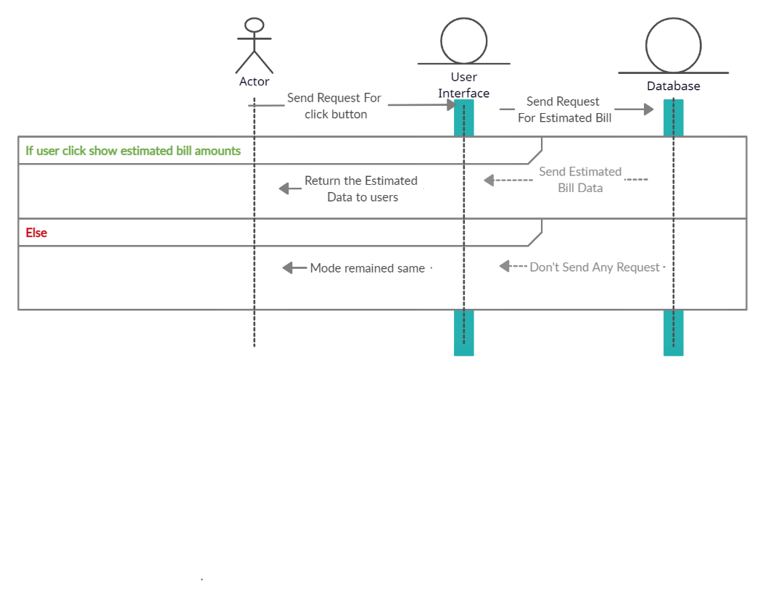

Figure[4] Sequence Diagram of Show Estimated Bill Amounts.

## Automation on/off

4.5.1 Description and Priority

The user should be able to turn on and off the temperature automation option in the control Unit, which considers the specialized choices of the user that is obtained from the installation stage (user information) and can be changed later, at any time. In addition, regardless of whether the user enters information when the temperature control unit is on automation or not openweather.com using the site, it optimally adjusts the temperature of the house according to the weather in the region by pulling the weather data of the region where the user lives to the API. This feature can be used with a button on the central unit or with the mobile app via Bluetooth connection. When the automation is turned off, an average house temperature data is selected by default with the help of statistics collected in the region. It can rate on relative scale as 7.

4.5.2 Stimulus/Response Sequences

After the automatic feature of the temperature control unit is turned off, a request is sent to the API. Then, the temperature level information requested by the user is received and processed. If the input is left blank by the user, the average temperature of the region is determined and the environment temperature is set to that level.

4.5.3 Functional Requirements

REQ-1: The temperature control unit should read the user's command and make the desired change.

REQ-2: The results obtained should be kept in the database.

REQ-3: If the automation feature is turned off, the system should connection the API.

## Querying the weather

4.6.1 Description and Priority

In order to obtain the data of the current weather and the possible predictions for the future in the intended location, Temperature Control Unit must perform regular (every 15 minutes) queries and save those data at the database. To do that Temperature Control Unit needs to perform requests to the API provided by openweather.com according to the address provided by the user. It can rate on relative scale as 5

4.6.2 Stimulus/Response Sequences

The TCU makes various requests to the given API based on the address information provided by the user. It records the expected weather information in the database according to the results of the requests made. This process may repeat periodically every 15 minutes as the data provided by the API is subject to change.

4.6.3 Functional Requirements

REQ-1 The temperature control unit must requests the API based on the provided user address.

REQ-2: The results obtained should be kept in the database.

REQ-3: The requests should continue at 15-minute intervals and the results should be updated.

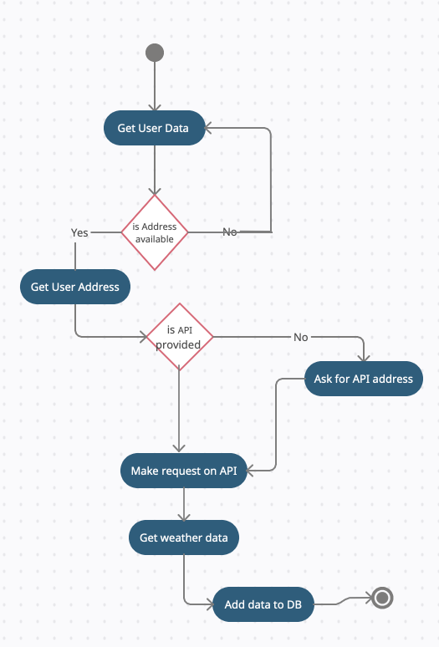

Figure[5] Activity diagram of Querying the weather.

## Energy Saving Mode

4.7.1 Description and Priority

In cases where the average electricity used by the system exceeds the average, a warning message is shown to the user about this usage and the user is asked to switch to the energy saving mode.

4.7.2 Stimulus/Response Sequences

When the system detects a certain electricity consumption, it sends a warning message to the user via the interface. "Switch to power saving mode?" In response to the answer to this question, the system takes action. This action adjusts the use of devices in the house and puts them in saving mode.

4.7.3 Functional Requirements

REQ-1: The system should measure electricity consumption.

REQ-2: The system should send a message to the user.

REQ-3: The system should put the system into energy saving mode or continue to operate in the same mode, depending on the response from the user.

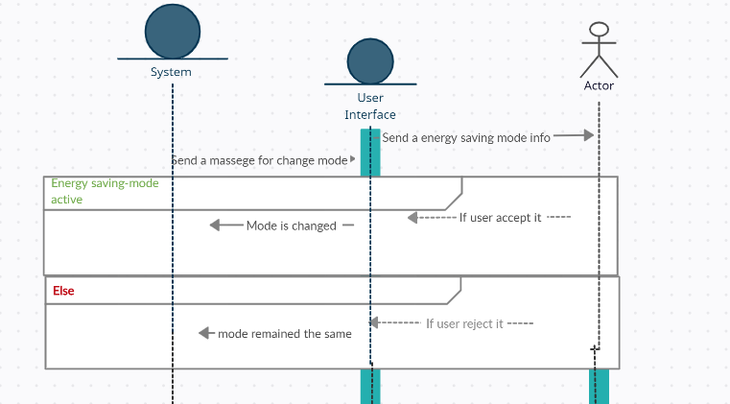

Figure[6] Sequence Diagram of Energy Saving Mode.

## Read logs

4.8.1 Description and Priority

The information entered for the automation of the houses and the data from the temperature control unit are collected in a database. Then, various reports are generated and analyzed with this data. With the results obtained, the efficiency of the system can be increased, and these results can be used for commercial purposes. Apart from these, budget and temperature reports are shared with the user at the end of each year.

4.8.2 Stimulus/Response Sequences

All information contained in the database is collected and evaluated. Then, a report is generated and presented to the manager. Apart from these, annual budget data kept in the database is collected and presented to the user in the user interface.

4.8.3 Functional Requirements

REQ-1: All transactions of the user should be kept in the database.

REQ-2: User's data should be processed and transferred to the admin panel in encrypted form.

REQ-3: The data generated annually should be displayed in the user interface.

Figure[7] Activity Diagram of ReadLogs.

## Emergency

4.9.1 Description and Priority

The Temperature Control Unit must be check and analyze the current temperature in the house periodically. In case of emergency (dangerously increased temperature) unit needs to send notification to the user and play an announcement sound in the house to make user take required precautions within the house. Since it is a high- priority feature, its rate can be considered in a relative scale as 9.

4.9.2 Stimulus/Response Sequences

If the temperature exceeds the normal (expected) limit in the house, the user must be warned with notifications and announcement sounds immediately. Moreover, if temperature continues to increase and eventually, the current temperature exceeds the critical limit (which is set to 100C as default) Unit needs to make a call to the Fire Department immediately with respect to the address information provided by user. Unit makes the call to the Fire Department by using a predefined and scripted speech with using the address information provided by the user.

4.9.3 Functional Requirements

REQ-1: The system should periodically check the temperature in the environment.

REQ-2: The system should interpret the expected temperature values during the day and set the expected maximum temperature for that day as the limit and inform the user when the environment exceeds this limit.

REQ-3: The system must be able to notify the fire department immediately when the critical limit is exceeded in the house (fire situation).

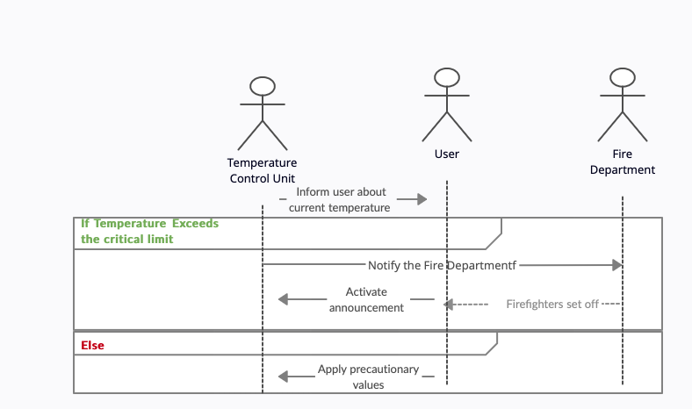

Figure [8] Sequence Diagram of Emergency.

## Network Loss Handling

4.10.1 Description and Priority

if there is an internet connection problem, the device continues to provide heat control of the house offline according to the current weather and economic situation by using this data. It can rate on relative scale as 9.

4.10.2 Stimulus/Response Sequences

The device keeps the temperature data in the house on a day-by-day basis, with data such as the weather on that day, the economic situation of the family. In case of any internet outage, it provides advice to the user to continue working offline using the stored data. If the user agrees, it continues to control the system in offline mode.

4.10.3 Functional Requirements

REQ-1: The system keeps data on the daily air temperature and, accordingly, the applied heating level.

REQ-2: The system assigns a request for offline mode to the user in case of connection loss.

REQ-3: The system starts to control the house temperature in an offline way according to the outside air temperature using the data.

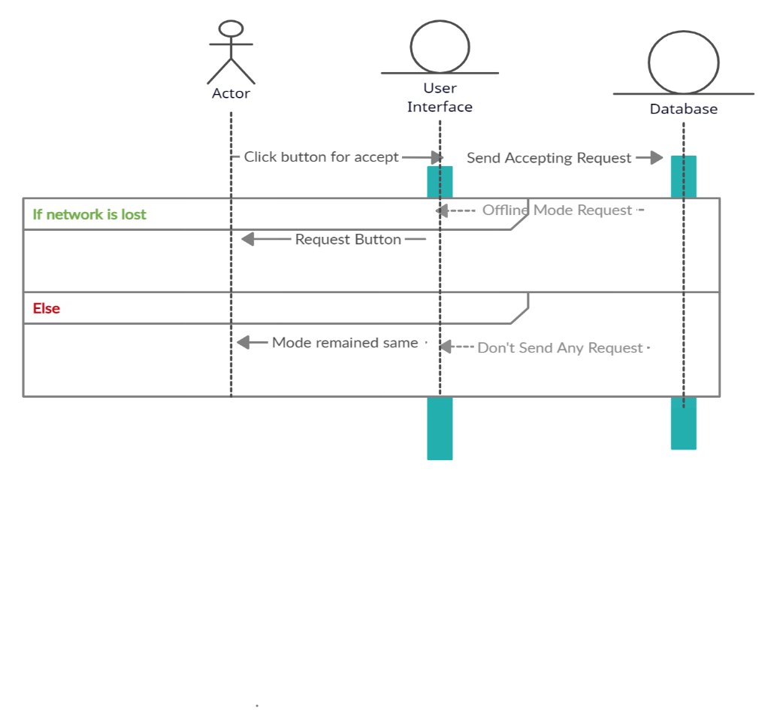

Figure[9] Sequence Diagram of Network Loss Handling.

## Show recommended adjustments

4.11.1 Description and Priority

Depending on the weather conditions at the address provided by the user, the recommended adjustments for the house ecosystem must be shown to user. The Temperature Control Unit regularly queries the current temperature, humidity, wind, and rain in the given location by sending requests to API (Querying the weather). So that user can easily change the current temperature settings to the recommended ones according to weather conditions in there. It can rate on relative scale as 3

4.11.2 Stimulus/Response Sequences

Weather forecasts in the relevant region are available in the database. The Temperature Control Unit evaluates the weather forecasts in the database, finds and interprets the optimal temperature levels in the ecosystem it is in. When these data are interpreted, the most accurate temperature values to be applied within the ecosystem are shown to the user. If the user deems it appropriate, he can change the system temperature depending on these data.

4.11.3 Functional Requirements

REQ-1 Weather forecasts in the database should be evaluated.

REQ-2: Depending on the evaluations made, the system should suggest the most appropriate temperature settings within the ecosystem to the user.

REQ-3: If the user finds the recommendations appropriate, the new temperature values should be changed by the system depending on the recommendations.

## Pair Smart Components

4.12.1 Description and Priority

The user can see the external smart components available in his home using a bluetooth connection. The user can optionally include and manage these components in his current system. Smart components are directly connected to the TCU, and the communication between the user and the components is also carried out by the TCU.It can rate on relative scale as 4.

4.12.2 Stimulus/Response Sequences

When the user wants to add a new component, the nearby components detected by the TCU are presented to the user. Desired smart components can be included in the ecosystem with the pair option. After these external components are included in the system, they can be controlled or observed by the user through the application.

4.12.3 Functional Requirements

REQ-1 Nearby components should be scanned by the TCU and the detected ones should be presented to the user.

REQ-2: Communication must be provided between the external components added to the system by the user and the TCU. In this context, the commands of the user should be transmitted to the relevant components via the TCU.

# Other Nonfunctional Requirements

## Performance Requirements

The majority of the process done by the temperature control units that we offer to users takes place in a Local Area Network (LAN). In this way, it should take less than a second for these processes to reach the user interface. On the other hand, for API services used externally, an internet connection is required. Locations of API services are important for fast communication. For this reason, the main servers should be close to the customer's location and a previously unused port should be opened for communication.

## Safety Requirements

Access to the system's user interface should be restricted. For this reason, a user login panel should be created, and a password must be requested from the user. The password should be hidden while the user enters the password on the panel. For this reason, each entry can be change with an asterisk. Also, users should pay attention to expenses. The product can spend maximum energy to reach the desired temperatures. For this reason, information should be provided that will attract the user's attention in user interface.

## Security Requirements

For the user to log into the system, user must enter a password and username. Afterwards, this information should be kept encrypted in the database and no transactions should be allowed anonymously. In addition, extra precautions should be taken for the SSH protocol used for the administrator panel. Except for the password and user entries, special keys such as "id_rsa" must be created.

## Software Quality Attributes

Adaptability: The system can easily adapt to changes made in user or temperature information.

Availability: The system must be accessible under all conditions.

Correctness: The system must satisfy all the requirements.

Flexibility: Users are not restricted by strict restrictions while using the system.

Interoperability: The subsystems in the system must be interoperable under all conditions.

Maintainability: The system must be updated and changed as needed.

Portability: Information portability between subsystems can be realized easily.

Reliability: The system must be accessible, but everyone must have a certain level of access for personal information security.

Usability: The system is designed to satisfy all the needs of the users.

Robustness: When the system encounters any problem, it can handle it and does not cause any problems in quality assurance.

Testability: All functions of the system can be tested and pass these tests.

Reusability: The subsystems of the system are reusable, which increases the quality and sustainability of the system.

## Business Rules

User can access the system and they can perform these functions:

Log-in/Register

Add User Information

Pair Smart Components

Show Estimated Bill Amounts

Show Recommended adjustment

Automation on/off

Energy Saving Mode

Administrator can access the system and they can perform these functions:

Control Unit Implementation

Read Logs

Temperature Control Unit access the system and they can perform these functions:

Querying the weather

Network Loss Handling

Emergency

Fire Department also access the system and they can perform this function:

Emergency call

# Other Requirements

Since it is usual to experience situations such as internet disconnection and power outage in the system, disruptions may occur in the system in exceptional cases. Responsibility for these situations belongs to the user.

## Appendix A: Glossary

TCU: Temperature Control Unit

DB: Database

API: Application Programming Interface. It allows us to use properties of X application in the Y application.

## Appendix B: Analysis Models

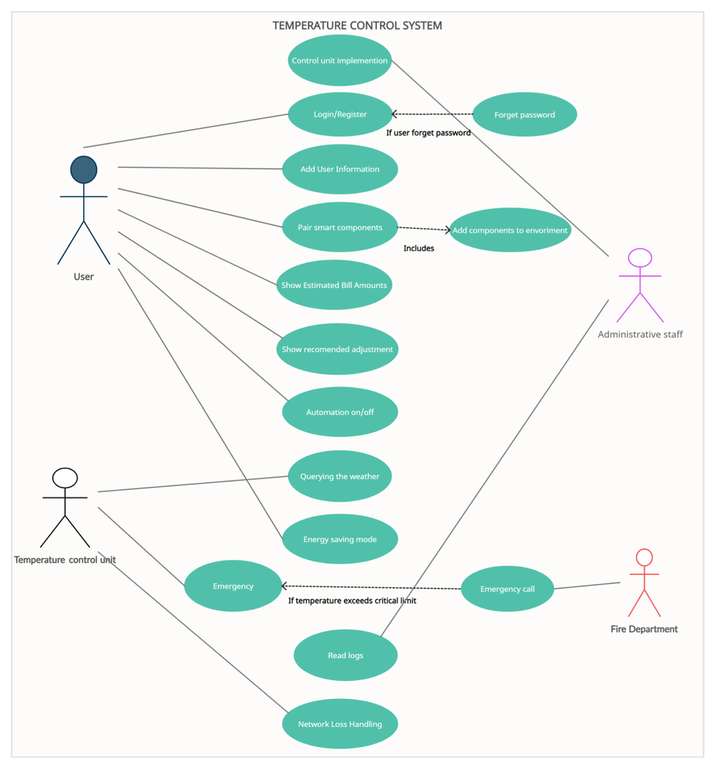

|  |  |
| --- | --- |
| Use Case | Emergency |
| Actor | Temperature Control Unit, Fire Department |
| Description | The Temperature Control Unit must be check and analyze the current temperature in the house periodically. In case of emergency (dangerously increased temperature) unit needs to send notification to the user and play an announcement sound in the house to make user take required precautions within the house. If the current temperature exceeds the critical limit (which is set to 100C as default) Unit needs to make a call to the Fire Department immediately with respect to the address information provided by user. Unit makes the call to the Fire Department by using a predefined and scripted speech with using the address information provided by the user. |

|  |  |
| --- | --- |
| Use Case | Control unit implementation |
| Actor | Administrator |
| Description | In order to control and analyze the temperature values in central and floor heating centers we need to connect our Temperature Control Unit (TCU) to them. To accomplish this required electronical connections must be made by the administrative staff in order to provide the communication between control unit and heat centers (Radiator, combi boiler etc.). Once the control unit implementation finished, user can pair any additional smart components to the Temperature Control Unit via Bluetooth connection. |

|  |  |
| --- | --- |
| Use case | Show recommended adjustments |
| Actor | User |
| Description | Depending on the weather conditions at the address provided by the user, the recommended adjustments for the house ecosystem must be shown to user. The Temperature Control Unit regularly queries the current temperature, humidity, wind, and rain in the given location by sending requests to the weather API (openweather.com). So that user can easily change the current temperature settings to the recommended ones according to weather conditions in there |

|  |  |
| --- | --- |
| Use-case | Querying the weather |
| Actor | Temperature Control Unit |
| Description | In order to obtain the data of the current weather and the possible predictions for the future in the intended location, Temperature Control Unit must perform regular (every 15 minutes) queries and save those data at the database. To do that Temperature Control Unit needs to perform requests to the API provided by openweather.com according to the address provided by the user. |

|  |  |
| --- | --- |
| Use-case | Automation on/off |
| Actor | User |
| Description | The user should be able to turn on and off the temperature automation option in the control Unit, which considers the specialized choices of the user that is obtained from the installation stage (user information) and can be changed later, at any time. In addition, regardless of whether the user enters information when the temperature control unit is on automation or not openweather.com using the site, it optimally adjusts the temperature of the house according to the weather in the region by pulling the weather data of the region where the user lives to the API. This feature can be used with a button on the central unit or with the mobile app via Bluetooth connection. When the automation is turned off, an average house temperature data is selected by default with the help of statistics collected in the region. |

|  |  |
| --- | --- |
| Use-case | Add User Information |
| Actor | User |
| Description | In order for the temperature control unit to work at maximum efficiency and to use the automation feature, some data must be obtained from the user. The user can enter information such as the number of rooms, the number of people living in the house, the desired temperature level or average of the rooms, the order of importance of the rooms. In addition, the user can enter the budget information and with this information, the system focuses on maximum efficiency without exceeding the budget limits. Apart from these, this information is kept anonymous and used for general reporting. |

|  |  |
| --- | --- |
| Use-case | Read Logs |
| Actor | Administrator |
| Description | The information entered for the automation of the houses and the data from the temperature control unit are collected in a database. Then, various reports are generated and analyzed with this data. With the results obtained, the efficiency of the system can be increased, and these results can be used for commercial purposes. Apart from these, budget and temperature reports are shared with the user at the end of each year. |

|  |  |
| --- | --- |
| Use-case | Show Estimated Bill Amounts |
| Actor | User |
| Description | The device keeps the amount of electricity spent on heating in each room on a monthly basis and, accordingly, calculates the average monthly bill payment amount and presents it to the user. It also shares data with the user, such as how much electricity is spent on heating which room and how much this affects the bill. In addition, it provides the user with options based on the calculated average bill amount and can adjust the heating system in the home according to the user's economical situation, and provide efficient heating to match the user's monthly income. |

|  |  |
| --- | --- |
| Use-case | Network Connection Problem |
| Actor | Temperature Control Unit |
| Description | The device keeps the temperature data in the house on a day-by-day basis, with data such as the weather on that day, the economic situation of the family. When there is an internet connection problem, the device continues to provide heat control of the house offline according to the current weather and economic situation by using this data. The heating system continues to work efficiently, as it saves the heating data of the house in the database. |

|  |  |
| --- | --- |
| Use-case | Login/Register |
| Actor | User |
| Description | Users who are a member or want to become a new member can become a member of the application with this interface or log in to the system with their username and password. An account verification e-mail is sent to each new member. Once this email is confirmed, the user becomes a member of the system. If the username or security key entered by the user is incorrect, a warning message is displayed. In such a case, the user can log in to the system with the help of a new security key with the verification code to be sent to the e-mail address or phone number by clicking on the "Forgot Password" option. |

|  |  |
| --- | --- |
| Use-case | Energy saving mode |
| Actor | User |
| Description | In cases where the average electricity used by the system exceeds the average, a warning message is shown to the user about this usage and the user is asked to switch to the energy saving mode. Also, the user can turn it on this mod without a warning message. It can set hours for this and enable the system to switch to this mode autonomously. |

|  |  |
| --- | --- |
| Use-case | Pair Smart Components |
| Actor | User |
| Description | The user pairs various heat devices in the house with the unit via Bluetooth, WIFI or internet connection. These introduced devices are included in the environment of the application and enter the system. In this way, the application can control the devices simultaneously or separately from the device it wants. In addition, the devices added to the automation group can be set manually by the user or automatically by the application. |

## Appendix C: To Be Determined List

To be determined list:

The comments and suggested settings offered to the user can be improved with artificial intelligence applications and made more optimal.

In addition to a mobile application, a website can be designed where the user can log in and use the same features.

Individuals in the same household may have different user accounts, and in this structure, a feature that only parents control and children have limited access to can be added.